Olde English Consortium
1014 McCandless Road, Chester, South Carolina 29706
Phone (803) 385-5143 * Fax (803) 385-2174
FanningOEC@gmail.com
www.oldeenglishconsortium.org

Has the Uniform (School) Start Date

Boosted Tourism in South Carolina?

A Report by the Olde English Consortium

Chief Researcher and Author: Leland Graham

Michael W. Fanning, Ph.D., Executive Director
Olde English Consortium

Serving Cherokee, Chester, Chesterfield, Clover, Fairfield, Lancaster, & York Schools and USC Lancaster
Has the Uniform Start Date Boosted SC Tourism?
A Report by the Olde English Consortium
Chief Researcher and Author: Leland Graham

The South Carolina Early School Start Dates and the South Carolina Travel and Tourism Industries (Morse Report) submitted to the South Carolina Department of Education’s Uniform School Start Date Task Force in 2002 blamed increasingly early school start dates for certain declines in tourism indicators, especially in the “lost month” of August. Using the same data cited by the report, the Olde English Consortium seeks to determine whether the Uniform Start Date, in effect since the summer of 2007, has had any substantive effect on those numbers.

The Morse Report argued that earlier start dates were responsible for declining August hotel occupancy rates (1997-2002), and that there was no corresponding increase in May occupancy rates to offset the lost revenue (p. 5). If the Morse Report’s conjecture was true, we would anticipate seeing August occupancy rates increase since 2007 without an offsetting decline in May. According to the same data used in the original report, it appears that this projection did not bear out.

Fig. 1
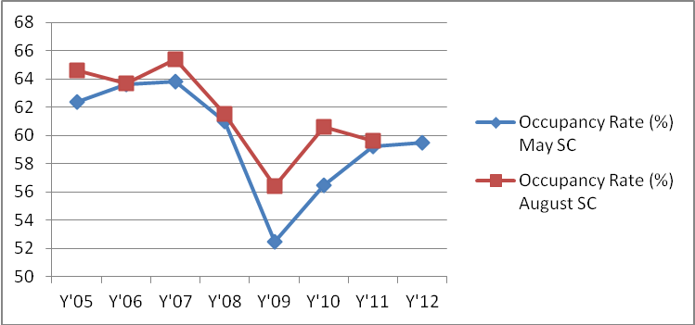

Fig. 2
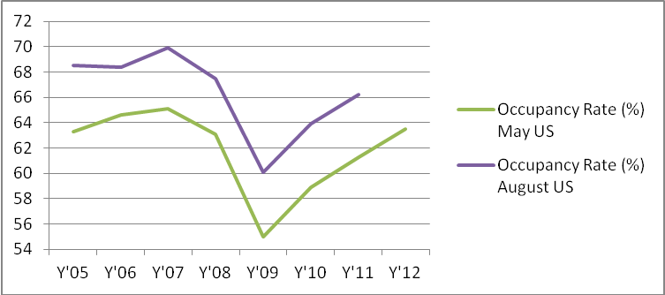

Hotel Occupancy Rate, Pre and Post USD
[complete May/August numbers, taken from SC PRT, presented in Appendix 1]

Before the introduction of Uniform Start Date (USD), August occupancy rates declined from 64.6% in 2005 to 63.7% in 2006. However, this was completely offset by an increase in May, as occupancy rates went from 62.4% in 2005 to 64.1%. Overall, the average summer occupancy (May through August) hardly changed. The first August after USD (2007), occupancy increased by 1.7% to 65.4%. However, the first May after USD (2008), occupancy fell to 61%, a 2.8% decrease from the previous year. This suggests that, if start dates have a correlative effect on tourism as industry lobbyists claim, the USD hurts May occupancy rates more than it improves August rates, creating a net drag on the tourism industry.

The data for the subsequent years becomes a little more complicated, as the global, national, and state economy experienced a sudden downturn in September of 2008 that continues to this day. However, by comparing May and August occupancy rates in South Carolina to the national figures, we believe we can work through the noise. Before the introduction of USD, May occupancy rates in South Carolina lagged about 1.1% behind national figures (63.26% vs. 64.33% from 2005-2007). Since USD went into effect, that gap has more than doubled to 2.62% (57.74% vs. 60.36%). Obviously, one interpretation of this data might simply be to suggest that the effects of the economic downturn on South Carolina’s tourism industry have been worse than on the nation as a whole. If that were the case, we would expect to see a similarly pronounced gap develop between state and national numbers in August. Instead, we see that the pre-USD gap of 4.3% has only marginally increased to 4.8%, despite the economic downturn. Once again, it appears that small increases in August numbers since USD are muted by larger decreases in May, resulting in a net loss for state tourism.

The tourism industry argued for the introduction of USD by pointing out that while August tourism numbers tend to stay consistently higher than May numbers throughout the US (see fig. 2), this trend was not reflected in South Carolina (see fig. 1). However, despite the later start dates across the state, South Carolina’s tourism figures remain idiosyncratic – in 2011, May occupancy rates equaled those of August, just as they had in 2006 before the introduction of the Uniform Start Date. Our reading of occupancy data suggests that little correlation exists between school start dates and hotel occupancy in the summer months, and is a net negative. The August tourism boom predicted by the Morse Report has simply not taken shape.

SC Accommodations Tax Revenue, Pre and Post USD
[complete data, taken from SC PRT, presented in Appendix 2]

The Morse Report argued that earlier school dates were responsible for downward trend in August’s Accommodation Tax share in the summer months (pg. 6). Focusing especially on a sharp drop in revenue collected between July and August, the Morse Report suggested that the introduction of the USD would raise August’s share and increase net revenues without an offsetting loss in other summer months from later release dates. In fact, while August’s summer tax share did increase in the three summers after USD, it has since declined to pre-USD levels. Similarly, the difference in July to August revenue has also returned to pre-USD levels. If school start dates truly impacted the tourism industry, those gains would have been sustained and not evanescent. Once again, the fluctuating figures suggest that school start dates have no discernible impact on the tourism industry.

Fig. 3
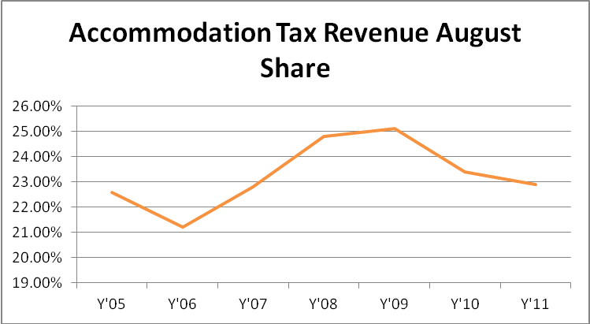

Fig. 4
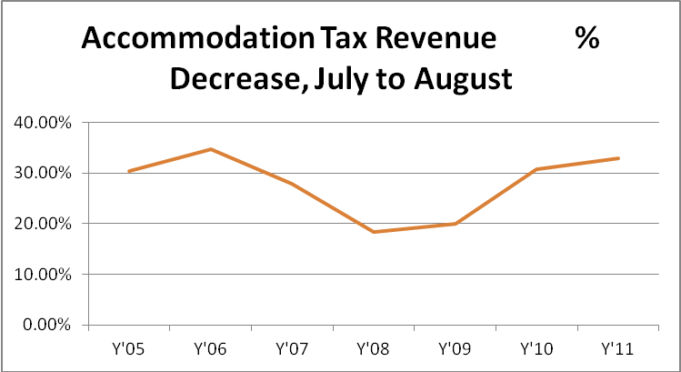
Furthermore, if we can read any impact of the Uniform Start Date into the numbers, it suggests that yet another of the Morse Report’s predictions has proven false. The main argument of for pushing back start dates was that gains in August numbers would not be offset by declines in other months. However, while the average accommodations tax revenue collected in August has increased since USD there has been a corresponding decrease in May. Given the general upward trend in June and July, we find it doubtful that later start dates are responsible for the August increase. However, the decline in May is entirely inconsistent with the general trend. Could later release dates be responsible? Has the USD hurt May tourism while producing no offsetting gain in other months?

Fig. 5
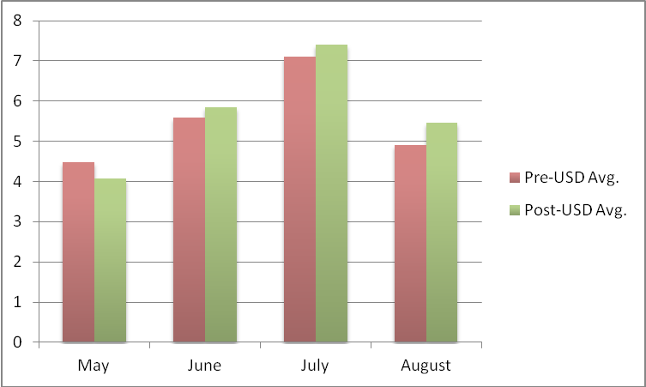

SC Admissions Tax Revenue, Pre and Post USD
[complete data, taken from SC PRT, presented in Appendix 3]

A final data set in the Morse Report looked at Admissions Tax Revenue in the summer months to look for a possible impact of early start dates on amusement and theme parks. Once again, the Report argued that introduction of a later Uniform Start Date would increase revenue in August without corresponding decreases in other months. Once again, the data collected since the USD contradicts that claim. There has been a notable increase in admissions tax revenue in August since the introduction of the USD. Perhaps, then, later start dates do allow more families to go to amusement parks in August. However, it would be equally logical to contend that later release dates keep these same families from going to amusement parks earlier in the year. In fact, comparing the August numbers to the May numbers (fig. 6) we see this is essentially what happened. In fact, May is the only month that is performing worse post-USD than pre, and this has kept total revenues flat, inconsistent with the gains predicted by the Morse Report (fig. 7)

Fig. 6
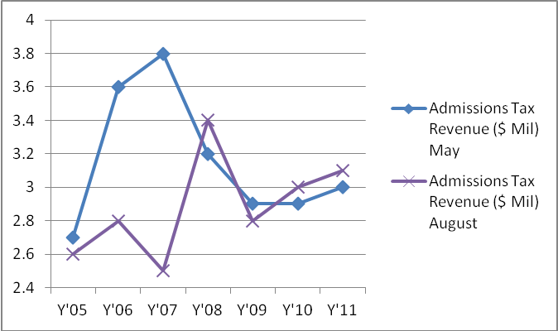

Fig. 7
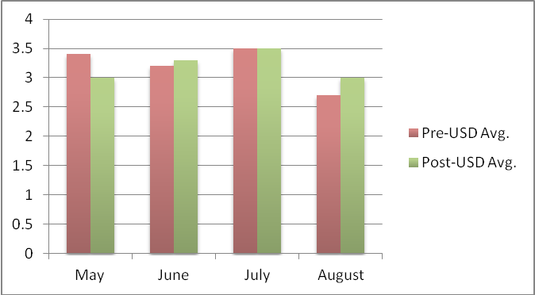

We can further validate that contention by looking at the revenue share in May/August against total summer revenue. According to the predictions in the Morse Report, we would have expected this share to increase, since August numbers would go up while May numbers would remain steady. But what actually happened? After a single year spike in 2008, the May/August revenue share has declined even further than average pre-USD levels. Once again, any impact that Uniform Start Dates has had on tourism seems to be, at most, a matter of shuffling the deck. Increased traffic later in the summer is offset by decreased traffic earlier in the summer.

Fig. 8
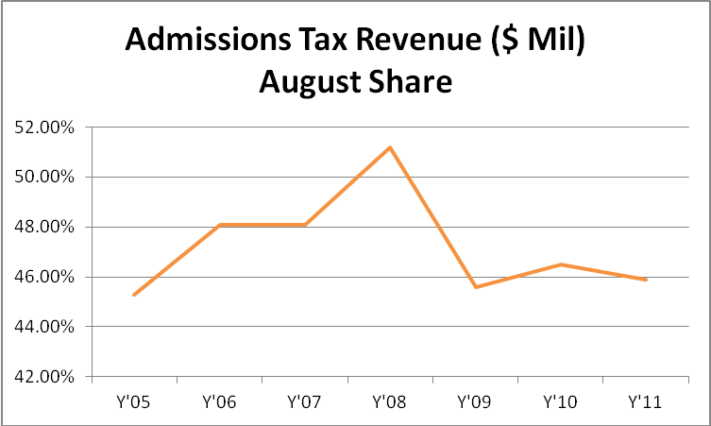

Conclusions

Most arguments presented by the industry lobbyists for a Uniform Start Date, like suggesting that earlier starts harmed not only tourism, but also students, teachers, and public education itself by creating “shorter summers,” seemed to pervert logic. Since the school year is already of a uniform length, early start dates cannot in themselves create “shorter summers,” since they have coincided with earlier release dates, too. The Morse Report itself often found itself creating linguistic convolutions to make a similarly specious argument. Over and over, it asserts South Carolina families are losing “summer August vacation time,” later conflating this with “shorter vacation time.”

How could they miss the obvious fact that earlier start dates correspond to earlier release dates, and have no overall impact on anyone’s vacation time? Schools are in sessions for the same number of days, regardless of start and release dates. Thus, we would expect that earlier start dates, corresponding to earlier release dates, would simply redistribute tourism dollars from later to earlier in the summer, and vice verse with later starts and releases. The tourism lobbyists argued that a distinctly counterintuitive result would occur instead: tourism would increase later in the summer, but there would be no corresponding decline earlier. They used the Morse Report to substantiate their claims.

In fact, in the five years since the introduction of the Uniform Start Date, the same data presented by industry lobbyists and the Morse Report has proven their hypothesis false. It is the belief of the Consortium that the start dates of schools across South Carolina have little to no bearing on the strength of the state’s tourism industry in August or in any other month. If anything, the data presented above suggests that any correlative effect between USD and South Carolina tourism has been neutral or negative, as gains made in August have been more than offset by losses in May.

APPENDIX 1

Occupancy Rate (%)
 | May SC | August SC | May US | August US
Y'05 | 62.4 | 64.6 | 63.3 | 68.5
Y'06 | 63.6 | 63.7 | 64.6 | 68.4
Y'07 | 63.8 | 65.4 | 65.1 | 69.9
Y'08 | 61 | 61.5 | 63.1 | 67.5
Y'09 | 52.5 | 56.4 | 55 | 60.1
Y'10 | 56.5 | 60.6 | 58.9 | 63.9
Y'11 | 59.2 | 59.6 | 61.3 | 66.2
Y'12 | 59.5 |  | 63.5

Source: SC PRT (http://www.scprt.com/our-partners/tourismstatistics.aspx)

APPENDIX 2

Accommodation Tax Revenue ($ Mil)
 | May | June | July | August | $ Decrease, July to August | % Decrease, July to August | August Share
Y'05 | 4.3 | 5.2 | 6.9 | 4.8 | 2.1 | 30.40% | 22.60%
Y'06 | 4.8 | 5.5 | 7.2 | 4.7 | 2.5 | 34.70% | 21.20%
Y'07 | 4.3 | 6.1 | 7.2 | 5.2 | 2 | 27.80% | 22.80%
Y'08 | 4.3 | 6.2 | 7.1 | 5.8 | 1.3 | 18.30% | 24.80%
Y'09 | 3.7 | 5.3 | 6.5 | 5.2 | 1.3 | 20% | 25.10%
Y'10 | 4.1 | 5.8 | 7.8 | 5.4 | 2.4 | 30.80% | 23.40%
Y'11 | 4.2 | 6.1 | 8.2 | 5.5 | 2.7 | 32.90% | 22.90%
Pre-USD avg. | 4.47 | 5.6 | 7.1 | 4.9
Post-USD avg. | 4.07 | 5.85 | 7.4 | 5.47

Source: SC PRT (http://www.scprt.com/our-partners/tourismstatistics.aspx)

APPENDIX 3

Admissions Tax Revenue ($ Mil)
 | May | June | July | August | May/Aug Share
Y'05 | 2.7 | 3.1 | 3.3 | 2.6 | 45.30%
Y'06 | 3.6 | 3.4 | 3.5 | 2.8 | 48.10%
Y'07 | 3.8 | 3.1 | 3.7 | 2.5 | 48.10%
Y'08 | 3.2 | 3.2 | 3.1 | 3.4 | 51.20%
Y'09 | 2.9 | 3.2 | 3.6 | 2.8 | 45.60%
Y'10 | 2.9 | 3.3 | 3.5 | 3 | 46.50%
Y'11 | 3 | 3.4 | 3.8 | 3.1 | 45.90%
Pre-USD Avg. | 3.4 | 3.2 | 3.5 | 2.7
Post-USD Avg. | 3 | 3.3 | 3.5 | 3

Source: SC PRT (http://www.scprt.com/our-partners/tourismstatistics.aspx)

