2025 Champions for Education Award Timelines, Description

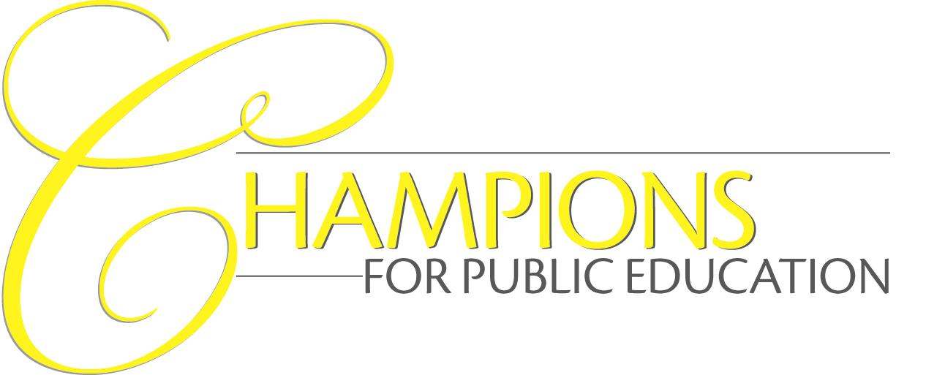
South Carolina School Boards Association (SCSBA)

Purpose
To recognize community residents, organizations or local businesses/industries (external benefactors) whose support of and contributions to public education have significantly benefited the entire school district or public schools statewide.

Recognition and Awards Process
Champions for Public Education award presentations take place locally, either as part of the board’s regular meeting or at a special event in the district as determined by the local board or by a member of the association’s board of directors or senior staff. In addition to the special local recognition, SCSBA assists district staff in providing news releases to local media at the request of the winner. SCSBA may further highlight winning programs in SCSBA publications, on the SCSBA website and at Boardmanship Institute (BI) workshops.

The timeline for submissions and presentations follows.
- March 17, 2025 _ deadline for nomination to SCSBA
May 2025 _ action to Board of Directors
June 2025 _ presentation to award recipient(s)
- July 1, 2025 _ deadline for nomination to SCSBA
Aug. 2025 _ action by Board of Directors
Sept. 2025 _ presentation to award recipient(s)
- Oct. 3, 2025 _ deadline for nomination to SCSBA
Dec. 2025 _ action by Board of Directors
Jan. 2026 _ presentation to award recipient(s)
- Dec. 1, 2025 _ deadline for nomination to SCSBA
Jan. 2026 _ action by Board of Directors
Feb. 2026 _ presentation to award recipient(s)

Eligibility
South Carolina residents of school districts are eligible if they are not employed or receive compensation for services by the school district (volunteer their time, talents, etc.). Employees who volunteer their time to benefit the school district in other capacities unrelated to their jobs are also eligible. Nominees cannot include former or current school board members’ service, responsibilities or activities.

Judging Process
Judging of each entry is based on the award’s set criteria (see nomination form) and NOT against other school district entries. Nominees do not compete for a single award, as there could be multiple winners.

The SCSBA Awards Committee of the SCSBA board of directors serve as the judges. Once judged, the awards committee takes its final recommendations for approval to the association’s board of directors at its next quarterly meeting (see timeline and recognition above).

Instructions
See nomination and award criteria form for instructions.

For more information contact:
Angela Crosland, SCSBA Director of Communications, 800-326-3679 or acrosland@scsba.org.
SCSBA Champions for Public Education Nomination & Award Criteria Form

Name of School District Board: __________________________Date: _______________________

Name of person, organization, business, etc. for nomination: _______________________________

If nominee is an organization or business, name of key contact person: _______________________

Address of organization, business or individual nominated: _________________________________

Telephone Number of nominee: ____________________________________

Board member/district staff completing form: _______________ Phone Number: _______________

District size ___ Small (up to 2,999 students) ___ Medium (3,000 – 8,999) ___ Large (9,000+)

(for demographic purposes only)

Board chairman’s signature: _________________________________________________________
(certifies the school board’s support of nomination)

CRITERIA
Provide an overview/abstract describing why you believe this person/organization merits recognition and describe how your nominee meets the criteria listed below.

Use no more than one 8 ½ x 11 sheet for EACH criterion. Type double-spaced with a 250-word maximum per page.

The overview should read as a standalone. Address each of the three criteria concisely and factually, with specific examples. Provide your nominee’s name in the upper right-hand corner of each sheet.

- ABSTRACT/OVERVIEW: Describe why you believe this person/organization merits state recognition.
- LEADS: Shows leadership in support either of ongoing or special programs authorized by the school board or SCSBA.
- ADVANCES: Actively demonstrates concern and effectively works for the betterment of the school district or for public schools statewide.
- INSPIRES: Exhibits an understanding of public education’s importance to democracy and does his/her/its part to inspire support for quality public schools within the community or state.

Email the form along with narrative and supporting documents to Angela Crosland at acrosland@scsba.org or mail to SCSBA, 111 Research Drive, Columbia, SC 29203.

